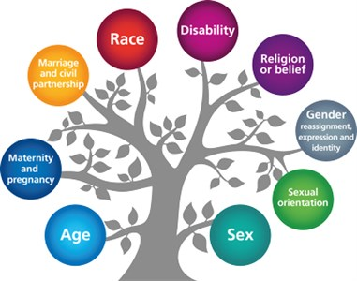
PROMOTING THE NINE PROTECTED CHARACTERISITICS

The Equality Act became law in 2010. It covers everyone in Britain and protects people from discrimination, harassment and victimisation. Everyone in Britain is protected. This is because the Equality Act protects people against discrimination because of the protected characteristics that we all have. Under the Equality Act, there are nine Protected Characteristics:

- Age
- Disability
- Gender reassignment
- Race
- Religion or belief
- Marriage or civil partnership
- Sex
- Sexual orientation
- Pregnancy and maternity
Under the Equality Act you are protected from discrimination:
- When you are in the workplace
- When you use public services like healthcare (for example, visiting your doctor or local hospital) or education (for example, at your school or college)
- When you use businesses and other organisations that provide services and goods (like shops, restaurants, and cinemas)
- When you use transport
- When you join a club or association (for example, your local tennis club)
- When you have contact with public bodies like your local council or government departments

The 9 Protected Characteristics are actively promoted in school through:
- Our school ethos statement and values
- Our school behaviour policy
- Conscious role modelling by all adults in the school community
- Engagement and communication with parents and carers
- Assemblies
- British Values
- Discussion within curriculum subjects
- Promoting articulation by building appropriate language and a coherent vocabulary
- PSHE lessons, including RSE
- RE lessons
- Sporting, Art and Cultural Events
- Pupil Voice
- Educational visits
- Real-life learning outside the classroom
- Visitors to school
- Extra-curricular activities, after-school clubs, charity work and work within the local community

