

**Intent:** At Abbey School, we aim for children to be fluent in the fundamentals of maths, are able to reason mathematically and be able to solve problem by applying their mathematics. These skills are embedded within maths lessons and developed consistently over time using lessons incorporating the ‘Big 5 ideas’ (coherence, representation and structure, mathematical thinking, fluency and variation). We are committed to ensuring that children are able to recognise the importance of maths in the wider world and that they are also able to use their mathematical skills and knowledge confidently in their lives in a range of different contexts.

**Maths at Abbey**

**EYFS**

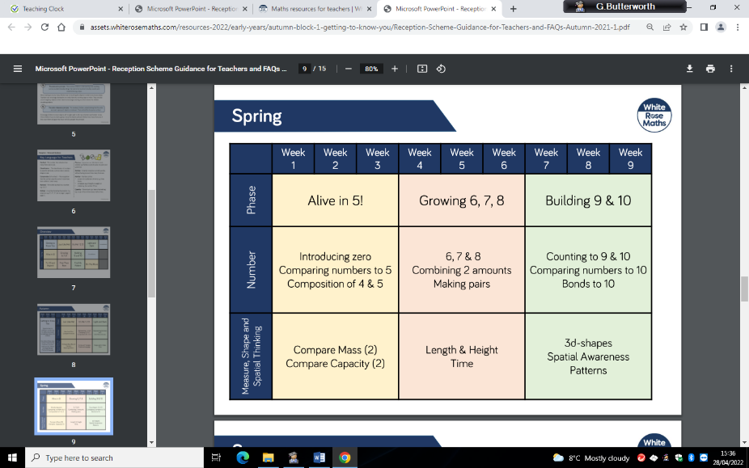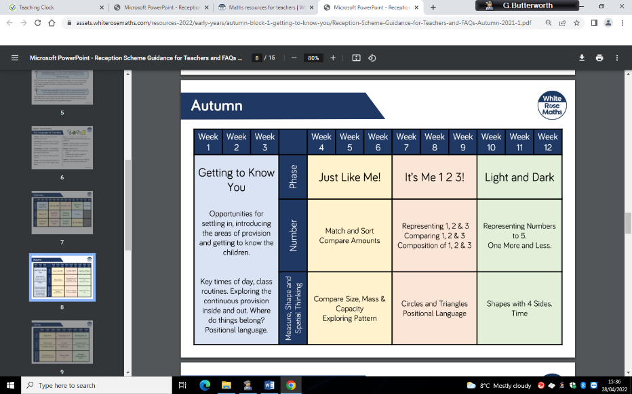

**What does maths like in EYFS?**

Maths in EYFS is based around a ‘mastery’ approach and focuses solely on the ‘big five’ ideas. The curriculum uses White Rose and NCETM supporting documents to resource, structure and plan lessons. We use the CPA approach (concrete, pictorial, abstract) to teach the children new mathematically concepts. Children are taught maths every day, with two pieces of evidence recorded per week whether this will be on a one to one basis or a small group. Some of the concrete resources you may see in EYFS are: numicon, cubes, numberlines, tens frames, five frames, seasonal objects.

**How do children remember learning in EYFS?**

Children watch lots of mathematically videos and songs to help them remember key facts/ concepts. Teachers ask questions pre lesson about previous learning. Most of the time the maths provision links to previous learning. In the EYFS classrooms, the working walls are updated regularly and are used to aid the children in remembering learning.

**How are children supported and challenged in Year One?**

Children are supported through the use of manipulatives during a lesson. Children are challenged by moving them on to the abstract version of the mathematically concept being taught. A lot of the time this is recorded on a whiteboard. Teachers and TAs will question and move the child’s learning on via a live intervention/extension as the maths activity is usually one to one or group based. We aim for an 80% success rate during a lesson. If children are not successful within the lesson an intervention will be given before the following lesson.

**Which manipulatives do you use?**

The main resources we use in EYFS are: numicon, cubes, numberlines, tens frames, five frames, seasonal objects.

