Mental Health Support for Outside of School

BIG WHITE WALL: For Stress & Anxiety.
Anonymous online community support. Site offers one to one with trained mental health professionals.
www.bigwhitewall.com.

CALM HARM: For Emotional Support & Self- Harm Reduction.
Tasks to help minimise self-harm and regulate emotions.
www.calmharm.co.uk.

CATCH IT APP: Anxiety & Depression.
App to help managing negative thoughts and promote positive thought processes.

CHILL PANDA APP: Reduce Worries
App to provide information and step by step guides for breathing techniques and exercises to calm the mind.

IESO: Online Therapy
Assists with anxiety, stress, low mood and much more. Online counselling
www.iesohealth.com/en-gb

MEE TWO: Mental Health Support
Online app to discuss issues affecting the lives of students. Anonymous advice available from experts.

YOUNG MINDS: Mental Health Support
Website providing support and online toolkits designed to help improve mental health. Online Blog.
youngminds.org.uk/

KOOTH: Online Counselling Support
Free online anonymous mental health support. Online crisis support. Articles and community blogs. Online journaling available.
www.kooth.com/

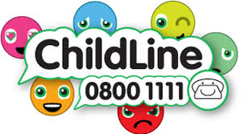 CHILDLINE: Online Line Information
Online and telephone counselling and support. Information and advice regarding a large range of topics. Online toolbox providing strategies and assistance.
www.childline.org.uk/

MIND: Information and Support for Mental Health Issues
Information, support and advice on all mental health needs.
www.mind.org.uk/information-support/for-children-and-young-people/

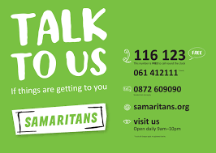 SAMARITANS: Crisis Support
Telephone, email and in person support. Offers crisis mental help support on a large range of issues.
https://www.samaritans.org/

