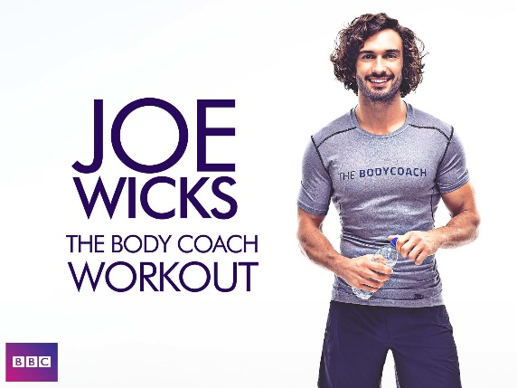

Federation of Abbey

Join Joe every day next week for a home workout.
Starting Monday 23rd March he is going to be hosting a free workout aimed at kids LIVE on his YouTube channel.
https://www.youtube.com/user/thebodycoach1/featured You don't need any equipment, just tune in to his YouTube channel at 9am each morning for a 30-minute, fun workout.

With the schools closed and with us all spending more time at home, it's more important than ever that we keep moving and stay healthy and positive. Exercise is an amazing tool to help us feel happier, more energised, and more optimistic. The workouts will be fun and suitable for all ages and even adults can get involved.

Below are some more workouts that you can do whist at home.

Reception
Kids Beginners Workout | The Body Coach
https://www.youtube.com/watch?v=mhHY8mOQ5eo

KS1 – Active 5 Minute
Kids Workout 1 https://www.youtube.com/watch?v=d3LPrhI0v-w&t=111s

Kids Workout 2 https://www.youtube.com/watch?v=SbFqQarDM50

Kids Workout 3 https://www.youtube.com/watch?v=pnKCGY9ZocA

Kids Workout 4 https://www.youtube.com/watch?v=fAUckPMJKSY

Kids Workout 5 https://www.youtube.com/watch?v=rN0h6EZd6TM

KS2 - Active 8 Minute

Workout 1 https://www.youtube.com/watch?v=uqLNxJe4L2I&list=PLyCLoPd4VxBszBLWgWMpt9kb5sKDXNX6M&index=2&t=3s

Workout 2
https://www.youtube.com/watch?v=EDC-plCTBbc&list=PLyCLoPd4VxBszBLWgWMpt9kb5sKDXNX6M&index=2

Workout 3
https://www.youtube.com/watch?v=9uw9ug_g-gM&list=PLyCLoPd4VxBszBLWgWMpt9kb5sKDXNX6M&index=3

Workout 4
https://www.youtube.com/watch?v=E5cmJpSFZB8&list=PLyCLoPd4VxBszBLWgWMpt9kb5sKDXNX6M&index=4

Workout 5
https://www.youtube.com/watch?v=EXt2jLRlaf8&list=PLyCLoPd4VxBszBLWgWMpt9kb5sKDXNX6M&index=5

