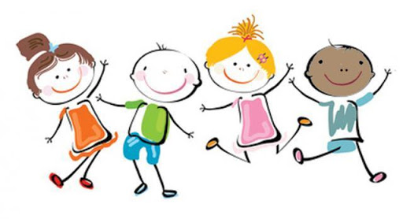
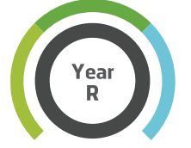
Click on the links for some great video-based ideas to do at home.
Dance
Just Dance 2018 - Waka Waka This Time For Africa
https://www.youtube.com/watch?v=gCzgc_RelBA
Fitness
Kids Beginners Workout | The Body Coach
https://www.youtube.com/watch?v=mhHY8mOQ5eo
Yoga
Mini the Puppy | Cosmic Kids Zen Den - Mindfulness for kids
https://www.youtube.com/watch?v=K7FUbTac_ds
Disney Dance-along
https://www.thisgirlcan.co.uk/activities/disney-workouts/

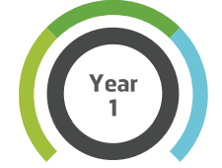
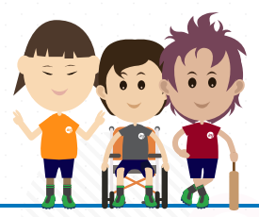

Click on the links for some great video-based ideas to do at home.
Dance
Just Dance 2018 - Waka Waka This Time For Africa
https://www.youtube.com/watch?v=gCzgc_RelBA
Home Fitness
5 Minute Move Featuring Betsy | The Body Coach TV
https://www.youtube.com/watch?v=u0_1QBQ8Syk
Yoga
Thought Bubbles | Cosmic Kids Zen Den - Mindfulness for kids
https://www.youtube.com/watch?v=xUUq0HuSLS0
Home Challenges
https://primarypeplanning.com/home-pe-ks1-challenge-activities/
Disney Dance-along
https://www.thisgirlcan.co.uk/activities/disney-workouts/

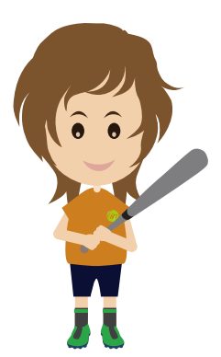

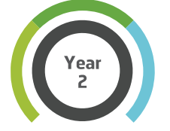

Click on the links for some great video-based ideas to do at home.
Dance
Let's Dance: I am Alive - will.i.am
https://www.youtube.com/watch?v=2pgR87RVD14
Home Fitness
5 Minute Move | Kids Workout 1 | The Body Coach TV –
https://www.youtube.com/watch?v=d3LPrhI0v-w
Yoga
Yes You Can! | Cosmic Kids Zen Den - Mindfulness for kids
https://www.youtube.com/watch?v=jzYtNWjQiK0
Home Challenges
https://primarypeplanning.com/home-pe-ks1-challenge-activities/
Disney Dance-along
https://www.thisgirlcan.co.uk/activities/disney-workouts/

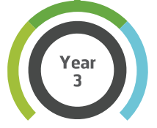

Click on the links for some great video-based ideas to do at home.
Dance
Macarena. Just Dance 2015
https://www.youtube.com/watch?v=zyIXQsDY9NE
Home Fitness
5 Minute Move Featuring Francesca | The Body Coach TV
https://www.youtube.com/watch?v=hvJXQT4gowg
Yoga
Popcorn the Dolphin | A Cosmic Kids Yoga Adventure!
https://www.youtube.com/watch?v=YR1OxBk8BF4
Home Challenges
https://primarypeplanning.com/home-pe-ks2-activities/
Disney Dance-along
https://www.thisgirlcan.co.uk/activities/disney-workouts/

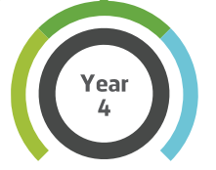

Click on the links for some great video-based ideas to do at home.
Dance
Just Dance 4 What Makes You Beautiful
https://www.youtube.com/watch?v=dpY4ZTV7Fm0
Home Fitness
Active 8 Minute Workout Featuring Alfie | The Body Coach TV
https://www.youtube.com/watch?v=EXt2jLRlaf8
Yoga
Cosmic Kids Yoga Disco | Washing Machine Song!
https://www.youtube.com/watch?v=dw-0bmtDPnk
Home Challenges
https://primarypeplanning.com/home-pe-ks2-activities/
Disney Dance-along
https://www.thisgirlcan.co.uk/activities/disney-workouts/

Click on the links for some great video-based ideas to do at home.
Dance
Mambo No 5 - Just Dance Summer Party
https://www.youtube.com/watch?v=z_Sv7IQwBGo
Home Fitness
Active 8 Minute Workout Featuring Izzy | The Body Coach TV
https://www.youtube.com/watch?v=YIB2SJnBHBQ
Yoga
Harry Potter and The Philosopher's Stone | A Cosmic Kids Yoga Adventure!
https://www.youtube.com/watch?v=R-BS87NTV5I
Home Challenges
https://primarypeplanning.com/home-pe-ks2-activities/

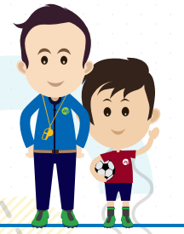
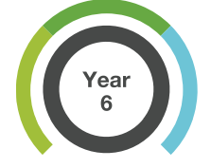

Click on the links for some great video-based ideas to do at home.
Dance
FRIENDS by Marshmello & Anne-Marie | Just Dance 2019
https://www.youtube.com/watch?v=Naj1SGmW0h0
Home Fitness
Active 8 Minute Workout Featuring Harry | The Body Coach TV
https://www.youtube.com/watch?v=TUp2_VAHIrI
Yoga
Minecraft | A Cosmic Kids Yoga Adventure!
https://www.youtube.com/watch?v=02E1468SdHg
Home Challenges
https://primarypeplanning.com/home-pe-ks2-activities/

